Data Communication and Network
LAB

FAROOQ AHMAD Experiment # 3
17L4407 Lab Report # 3
BEE-5A

SIMPLE TOPOLOGY IN NETWORK SIMULATOR VERSION-3
(NS-3)

INTRODUCTION
In this lab session, we were introduced to building up a simple topology in network simulator version 3 (ns 3) developing a point to point link between the server and the client passing through a router. Point to Point topology is the simplest topology that connects two nodes directly together with a common link. The entire bandwidth of the common link is reserved for transmission between those two nodes. The ns-3 CSMA device models a simple network in the spirit of Ethernet. A real Ethernet uses CSMA/CD (Carrier Sense Multiple Access with Collision Detection) scheme with exponentially increasing backoff to contend for the shared transmission medium. The ns-3 CSMA device and channel models only a subset of this.

OBJECTIVE

The course learning objective of this lab session was to introduce us to simple network topology point to point connection between two devices via router module. The processing objective is to build and analyze simple topology using point to point link.

DESIGN PROCEDURE
The task required to perform is
1. Create a third node (node 2), and set it up with an Internet stack.
2. Create a point-to-point link from node 1 to node 2.
3. The devices on this new link need addresses. Assign addresses on this link.
4. Create a new echo server and client, install the client on node 0 and the server on node 2, and
set up the necessary parameters for communication.
5. Modify the echo clients to send six packets each instead of a single packet.
6. Since we have more than just a single link, we need to set up routing. This can be done with
the line: Ipv4GlobalRoutingHelper :: PopulateRoutingTables();
Put this line after you assign the IP addresses on the links.
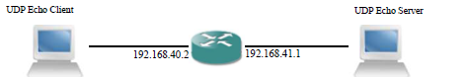
/* -*- Mode:C++; c-file-style:"gnu"; indent-tabs-mode:nil; -*- */
/*
* This program is free software; you can redistribute it and/or modify
* it under the terms of the GNU General Public License version 2 as
* published by the Free Software Foundation;
*
* This program is distributed in the hope that it will be useful,
* but WITHOUT ANY WARRANTY; without even the implied warranty of
* MERCHANTABILITY or FITNESS FOR A PARTICULAR PURPOSE. See the
* GNU General Public License for more details.
*
* You should have received a copy of the GNU General Public License
* along with this program; if not, write to the Free Software
* Foundation, Inc., 59 Temple Place, Suite 330, Boston, MA 02111-1307 USA
*/

#include "ns3/core-module.h"
#include "ns3/network-module.h"
#include "ns3/internet-module.h"
#include "ns3/point-to-point-module.h"
#include "ns3/applications-module.h"
using namespace ns3;
NS_LOG_COMPONENT_DEFINE ("FirstScriptExample");
int
main (int argc, char *argv[])
{
Time::SetResolution (Time::NS);
LogComponentEnable ("UdpEchoClientApplication", LOG_LEVEL_INFO);
LogComponentEnable ("UdpEchoServerApplication", LOG_LEVEL_INFO);

NodeContainer nodes;
nodes.Create (3);

PointToPointHelper pointToPoint1,pointToPoint2;
pointToPoint1.SetDeviceAttribute ("DataRate", StringValue ("8Mbps"));
pointToPoint1.SetChannelAttribute ("Delay", StringValue ("8ms"));
pointToPoint2.SetDeviceAttribute ("DataRate", StringValue ("8Mbps"));
pointToPoint2.SetChannelAttribute ("Delay", StringValue ("4ms"));

NetDeviceContainer devices1,devices2;
devices1 = pointToPoint1.Install (nodes.Get(0),nodes.Get(1));
devices2 = pointToPoint2.Install (nodes.Get(1),nodes.Get(2));
InternetStackHelper stack;
stack.Install (nodes);

Ipv4AddressHelper address1,address2;
address1.SetBase ("192.168.40.0", "255.255.255.0");
address2.SetBase ("192.168.41.0", "255.255.255.0");
Ipv4InterfaceContainer interfaces1 = address1.Assign (devices1);
Ipv4InterfaceContainer interfaces2 = address2.Assign (devices2);
Ipv4GlobalRoutingHelper :: PopulateRoutingTables();

UdpEchoServerHelper echoServer (9);
ApplicationContainer serverApps = echoServer.Install (nodes.Get (2));
serverApps.Start (Seconds (0.0));
serverApps.Stop (Seconds (5.0));

UdpEchoClientHelper echoClient (interfaces2.GetAddress (1), 9);
echoClient.SetAttribute ("MaxPackets", UintegerValue (6));
echoClient.SetAttribute ("Interval", TimeValue (Seconds (1.0)));
echoClient.SetAttribute ("PacketSize", UintegerValue (512));

ApplicationContainer clientApps = echoClient.Install (nodes.Get (0));
clientApps.Start (Seconds (0.0));
clientApps.Stop (Seconds (5.0));

Simulator::Run ();
Simulator::Destroy ();
return 0;
}
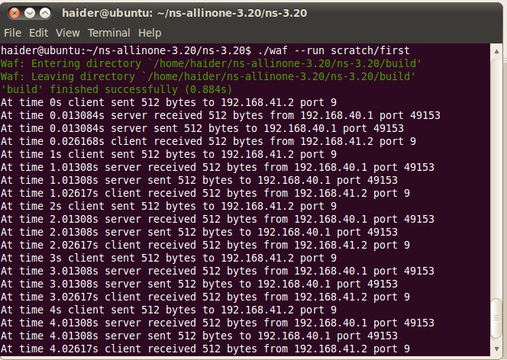

ISSUES
There were as such none issues.

CONCLUSION
This lab session was conducted successfully. The concepts of network simulator 3 were understood and used to build and analyze a simple topology using point to point link via router using Ipv4GlobalRoutingHelper :: PopulateRoutingTables();. The simple topology using point to point link between two devices passing through a router was build and analyzed with the help of routing table.

APPLICATIONS
NS3 helps to create various virtual nodes (i.e., computers in real life) and with the help of various Helper classes it allows us to install devices, internet stacks, application, etc to our nodes.
Topology is used in many branches of mathematics, such as differentiable equations, dynamical systems, knot theory, and Riemann surfaces in complex analysis. It is also used in string theory in physics, and for describing the space-time structure of universe.
Using NS3 we can create PointToPoint, Wireless, CSMA, etc connections between nodes. PointToPoint connection is same as a LAN connected between two computers. Wireless connection is same as WiFi connection between various computers and routers.

POST LAB
/* -*- Mode:C++; c-file-style:"gnu"; indent-tabs-mode:nil; -*- */
/*
* This program is free software; you can redistribute it and/or modify
* it under the terms of the GNU General Public License version 2 as
* published by the Free Software Foundation;
*
* This program is distributed in the hope that it will be useful,
* but WITHOUT ANY WARRANTY; without even the implied warranty of
* MERCHANTABILITY or FITNESS FOR A PARTICULAR PURPOSE. See the
* GNU General Public License for more details.
*
* You should have received a copy of the GNU General Public License
* along with this program; if not, write to the Free Software
* Foundation, Inc., 59 Temple Place, Suite 330, Boston, MA 02111-1307 USA
*/

#include "ns3/core-module.h"
#include "ns3/network-module.h"
#include "ns3/internet-module.h"
#include "ns3/point-to-point-module.h"
#include "ns3/applications-module.h"

using namespace ns3;

NS_LOG_COMPONENT_DEFINE ("FirstScriptExample");

int
main (int argc, char *argv[])
{
Time::SetResolution (Time::NS);
LogComponentEnable ("UdpEchoClientApplication", LOG_LEVEL_INFO);
LogComponentEnable ("UdpEchoServerApplication", LOG_LEVEL_INFO);

NodeContainer nodes;
nodes.Create (4);

PointToPointHelper pointToPoint1,pointToPoint2,pointToPoint3;
pointToPoint1.SetDeviceAttribute ("DataRate", StringValue ("8Mbps"));
pointToPoint1.SetChannelAttribute ("Delay", StringValue ("8ms"));
pointToPoint2.SetDeviceAttribute ("DataRate", StringValue ("8Mbps"));
pointToPoint2.SetChannelAttribute ("Delay", StringValue ("4ms"));
pointToPoint3.SetDeviceAttribute ("DataRate", StringValue ("8Mbps"));
pointToPoint3.SetChannelAttribute ("Delay", StringValue ("4ms"));

NetDeviceContainer devices1,devices2,devices3;
devices1 = pointToPoint1.Install (nodes.Get(0),nodes.Get(1));
devices2 = pointToPoint2.Install (nodes.Get(1),nodes.Get(2));
devices3 = pointToPoint3.Install (nodes.Get(1),nodes.Get(3));
InternetStackHelper stack;
stack.Install (nodes);

Ipv4AddressHelper address1,address2,address3;
address1.SetBase ("192.168.40.0", "255.255.255.0");
address2.SetBase ("192.168.41.0", "255.255.255.0");
address3.SetBase ("192.168.42.0", "255.255.255.0");
Ipv4InterfaceContainer interfaces1 = address1.Assign (devices1);
Ipv4InterfaceContainer interfaces2 = address2.Assign (devices2);
Ipv4InterfaceContainer interfaces3 = address3.Assign (devices3);
Ipv4GlobalRoutingHelper :: PopulateRoutingTables();

UdpEchoServerHelper echoServer (93);
ApplicationContainer serverApps = echoServer.Install (nodes.Get (2));
serverApps.Start (Seconds (0.0));
serverApps.Stop (Seconds (5.0));

ApplicationContainer serverApps2 = echoServer.Install (nodes.Get (3));
serverApps2.Start (Seconds (0.0));
serverApps2.Stop (Seconds (5.0));

UdpEchoClientHelper echoClient (interfaces2.GetAddress (1), 93);
echoClient.SetAttribute ("MaxPackets", UintegerValue (6));
echoClient.SetAttribute ("Interval", TimeValue (Seconds (1.0)));
echoClient.SetAttribute ("PacketSize", UintegerValue (512));

ApplicationContainer clientApps = echoClient.Install (nodes.Get (0));
clientApps.Start (Seconds (0.0));
clientApps.Stop (Seconds (5.0));

Simulator::Run ();
Simulator::Destroy ();
return 0;
}
